Custer County Fair Swine Ear Notch Information
Exhibitor Name:___________________________________________________________________
Breed: __________________________________________________________________________
Sex (barrow or gilt):________________________________________________________________
Notch Number (example 10-8):_______________________________________________________
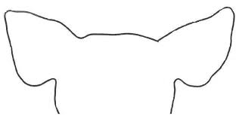
Left Right

Exhibitor Name:___________________________________________________________________
Breed: __________________________________________________________________________
Sex (barrow or gilt):________________________________________________________________
Notch Number (example 10-8):_______________________________________________________
Left Right

